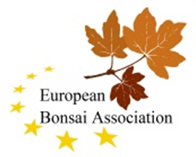

Dear EBA Members, Delegates and Contacts,
The 2023 EBA/BCA/ESA Convention, organised by CBA (Czech Bonsai Association) will take place from 20th – 23rd April 2023 at the beautiful town of Olomouc in the Czech Republic. Located on the Morava River, the city is the ecclesiastical metropolis and was a historical capital city of Moravia. Today, it is the administrative centre of the Olomouc Region and the sixth largest city in the Czech Republic. The historic city centre is well preserved and is protected by law as urban monument reservation.
The Convention will be one of the most important bonsai and suiseki event in Europe. It is a social event as well - bonsai enthusiasts from all over Europe will communicate with each other and share their experiences.
The EBA part of the convention runs from April 21th to 23rd.
Together with President Ivan Machacek and the organizing team of CBA we have done the necessary work to be able to hold an excellent EBA Convention integrated in the CBA Convention. In this letter you will find all the important information about the convention, including the prepared registration forms.
The exhibition will offer every EBA member country the opportunity to present exhibits in limited number. Beside the exhibition of bonsai, kusamono and suiseki there is an accompanying programme with demonstrations and the NTC. The New Talent Contest (NTC) with participants from all attending countries is an EBA contribution to the program. The organizers give visitors the opportunity to watch the creation of bonsai by Mr. Carlos van der Vaart and Mr. Milan Karpisek, two excellent bonsai artists.
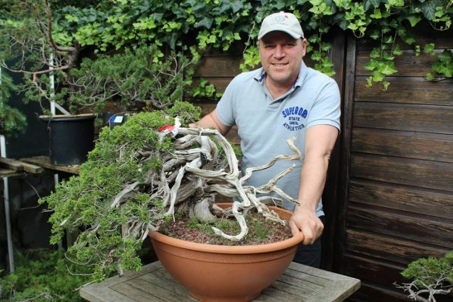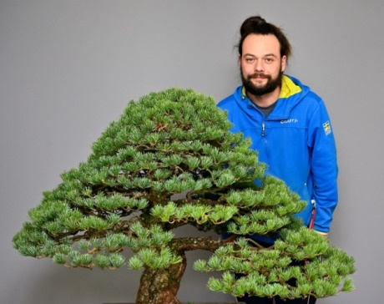
The venue is the “Flora Olomouc Trade and Fair Area” located in the centre of the town. The whole area (part of a big and nice park ) is fenced around and there are 13 entrance gates for visitors. (See attached plan). Polská ulice ( Polská street) leads to entrance 11. The turning point from Polská street will be marked by arrows and the label EBA 2023. Enclosed see the “MAP Polska street and turning point”. “Nájezd do areálu means: turning to exhibition area.”
Access to halls H and G via Entrance 11 is open for deliveries of exhibits by car on Thursday and Friday before 8:30 and after 18:00. It is possible to deliver the exhibits on Thursday or Friday evening until 20:00.
The Flora area is closed to cars from 8:30 to 18:00. Attention, only before and after that time it is possible to drive in to Halls G and H by car for delivering the exhibits.
If that is really not possible, i.e. an absolute exception, then there is a solution by the organizers. In the case of a delivery on early Saturday morning before the exhibition opens, it is agreed that these exhibits will be picked up by the organizers at gate 11. In order to avoid problems we ask you to inform us in writing, when submitting the registration, at what estimated time the delivery will take place.
However, this agreement is only a special exception for exhibitors who have a very long journey to Olomouc. In this case the organizers ask to drive by car with the exhibits to gate 11. They will take and transport even heavy trees to Hall G or H manually by little trolley to a very few reserved places of the exhibition.

If there are problems with the delivery of exhibits on site please contact: +420 602 424 030 ( Ivan Machacek). He speaks Czech, English, Polish and Slovak.

On Friday at 5:30 p.m. the official opening of the exhibition starts. The opening ceremony for the EBA part of the Convention will take place on Saturday at 10:00 am. (see program)
The “Evening Event” in form of a standing buffet will take place together with the Awarding Ceremony in Hall H. The ticket price for the “Evening Event” on Saturday evening at 7:00 p.m will be 40,00 € and has to be paid on site cash. There will be installed a CBA info desk inside of Hall H, where to pay.
Please let the organizers know if anyone of the exhibitors or visitors you know from your country is interested to participate in the Prize Ceremony and the Evening Event. Would you be so kind to ask them to send their names by email to info@cba-bonsai.cz latest until 31st of March 2023 (same time as the exhibit registration deadline). Registered tickets can be picked up at the CBA Information Desk until Friday evening. If there are still free places available by then, you can buy them directly on site at the desk.
Many traders will offer bonsai products, tools, pots, wire, plants, suiseki, kusamono, raw material and bonsai. The trading area is placed inside of a big tent in between halls G and H. Attached you find also the registration form and price list for traders: 44,00 € / m2 Tables, chairs, electricity etc. are available for fee.
Traders can still register and are welcome! Each member country is asked to make traders in their region aware of this possibility.
Ticket prices : The Entrance fee to the “Flora” event will be about 8,00 € per day. Tickets have to be paid on site. At gates 1 and 8 you can pay by credit card. All exhibitors and NTC participants will get free tickets. Anyone who paid the entrance fee can move freely throughout the exhibition grounds including Halls G and H as well as the newly upgraded Orangery in neighbourhood. Halls G and H are dedicated to bonsais, the Orangery will host suiseki.
1. Registration
Registration of bonsai:
According to the latest information, CBA offers exhibition space for approximately 60 exhibition places. This means that each participating member country can present at least 4 to 5 exhibits.
For the correct registration of the EBA bonsai each EBA Member selects 4 to 5 exhibits to present at the exhibition and is asked to submit the Bonsai Registration Form (copy/scan) for each exhibit to the organizers info@cba-bonsai.cz and to the EBA-Secretary detlef.mostler@aon.at. You will find the registration form attached.
If there are questions concerning the registration please contact either the secretary detlef.mostler@aon.at or Ivan Machacek machackovi@post.cz . The deadline for submitting the forms is the 31st March 2023.
We ask you to inform us as soon as possible of your planned participation in the exhibition. Each Member Country is allowed to bring 4 to 5 bonsai or shohin (-displays) to the exhibition. There is the possibility to present kusamono but only mixed between the bonsai exhibits.
As soon as possible please send an email to the secretary Detlef Mostler detlef.mostler@aon.at if you do not intend to bring bonsai to the exhibition. It is most important that we are able to fill up the allocated space for the EBA bonsai. In the case some EBA Members will not participate in the exhibition the board will ask other Members of EBA to bring more trees.
It is also important to tell us if you will bring less than 4 to 5 exhibits. If this is the case we can then pass on the unneeded space to other members.
Igor Barta from ESA is responsible for registering Suiseki. igor.barta@centrum.cz
2. NTC (EBA - New Talent Contest©)
Participants in the EBA - NTC have to be nominated by the Member Countries (EBA Delegates). The deadline will be 31st March 2023. Participants in the EBA New Talent Contest get free access to the exhibition, to all demonstrations and the Evening Event.
For the NTC, according to the EBA rules, the member countries that have registered a participant for the competition are asked to nominate also a judge for the evaluation of the best results. The evaluation process is managed and handled by Vaclav Novak, the EBA-Vice President. The result will be announced on the evening of the gala. The judges should have very good experience in evaluating bonsai. The documents for the evaluation are handed over at the NTC. Information on the rules of the NTC can be found on the EBA website. All participants in the NTC received information about the process. There will be a short briefing on site.
Send the name of your participant and the name of your country’s judge to detlef.mostler@aon.at and to machackovi@post.cz . If you don’t know the names until 31st March please send us a notice that your country will participate in any case in the NTC and you will give us the names as soon as possible. The NTC will take place on Saturday 22nd April 9:00 to 13:00 at the venue (Hall H ). There is also the possibility to make known the name of the judge on site.
In the case you don’t participate in the NTC please send a short notice about this fact to
detlef.mostler@aon.at as soon as possible.
As in the past accommodation must be organized (booked and paid) by the national association or by the participant himself!

3. EBA Meeting Delegate
Please submit to the Secretary before 2nd April 2019 the name of the official delegate competent for voting at the 2023 EBA - AGM. Please note that:
- The RTM is scheduled for Saturday, 22nd May, 15:00 – 17:00.
- The AGM will take place on Sunday, 23rd May, 10:00 – 12:00.
(See attachment: “EBA_CBA Convention 2023 Program final)
As soon as possible please send an email to the Secretary Detlef Mostler if no representative of your country will come to Olomouc to participate in the meetings (RTM or AGM) of the EBA Convention 2023. For all members there is the possibility for voting in the AGM to transfer the right to vote to another delegate of an EBA member who is present at the AGM. This delegation cannot be made to a member of the EBA Board.
4. Agenda RTM/AGM
Please inform the Secretary before 20th March 2023 about all your wishes and ideas for topics on the agenda so that they can be included.
The final agendas will be sent to the EBA Members at the beginning of April 2023.
5. Accommodation
On the booking websites you will find some links for hotels in Olomouc. The organizers recommend CENTRAL PARK FLORA near the venue (Recepce +420 585 422 200 +420 724 030 428 hotelflora@hotelflora.cz www.hotelflora.cz Krapkova 439/34, Nová Ulice) and Theresian Hotel (Javoříčská 5, Email: reception@theresian.cz Tel.: +420 581 113 113)
6. Transport
Olomouc, due to its location right in the middle of Moravia, is easily accessible by road and train. Arriving from Prague you can take the fast motorway via Brno, from Vienna (International Airport) there is also a speedy and comfortable connection on roads and partly motorways. Olomouc is also conveniently accessible by car from Poland and Slovakia.
Olomouc is also an important railway junction with the main station near the city center. Passengers have access to many high-speed trains, like the Intercity and Eurocity trains and passenger trains for regional transport, or the modern Pendolino train which provides a fast and convenient connection to the international airports of Prague and Ostrava. It takes you from Olomouc to Prague in just two and a half hours.
Transport in Olomouc itself is covered mostly by trams and buses with a dense transport network. They run all week and schedules are available at all public transport stops. Schedules can be also purchased, as well as the tickets, at selling points of the Transport Company of Olomouc (Dopravní podnik). Tickets are also available from ticket machines, at tobacconists or from the driver. Traveling by bus is in most cases cheaper than by train, sometimes also faster. For information about domestic and international timetables, see www.idos.cz

7. Promotion
For the success of each EBA Convention it is very important to motivate as many of the national bonsai enthusiasts to come to the Convention and attend this very interesting programme. Please promote this event within your national membership so that the EBA Convention 2023 in Olomouc will be a great success.
8. Contacts
Emails to:
President of CBA: Ivan Machacek machackovi@post.cz
EBA Secretary: Detlef Mostler detlef.mostler@aon.at
Websites:
European Bonsai Association: www.ebabonsai.com
Czech Bonsai Association: www.cba-bonsai.cz

Further contacts:
EBA Convention 2023 Convention team :
Convention manager : Ivan Macháček / ČBA pres.
Treasurer : Zbyňka drncová / ČBA treasurer
Design and installation : Libor Slatinka / ČBA Board
Program secretary, co ordinator : Jirka Novák / ČBA Board
Registration : Pavla Vranová / ČBA Board
Organisation on site : Richard Šrámek / Flora
Prize giving evening org.: Lukáš Nehyba / ČBA Board
ESA issues : Igor Bárta / ESA
NTC co ordinator : Václav Novák / ČBA Board
PR : Flora

Thank you all in advance for your answers by email.
After these many organizational notes, we only have to thank everyone who did a lot of work in the run-up to the EBA Convention 2023.
We look forward to seeing you in Olomouc!
Marc Noelanders | Detlef Mostler
EBA President | EBA Secretary
ZVR 565524462 European Bonsai Association "EBA" | Klagenfurt  February 2023

